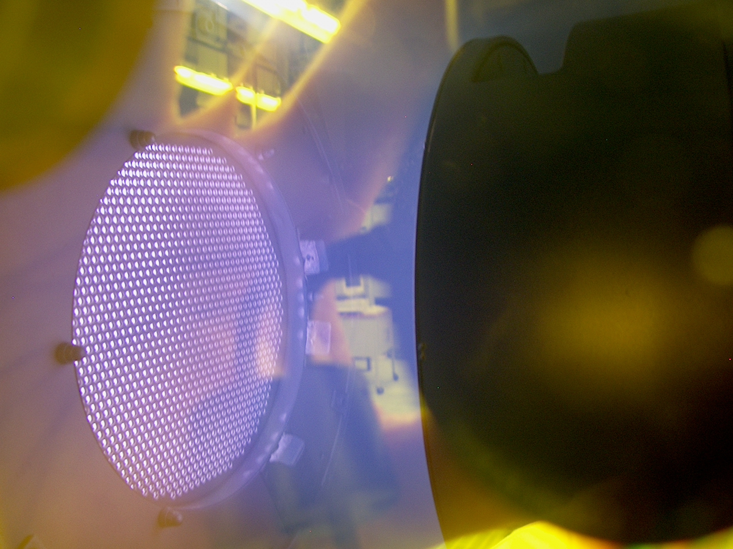


Height

Mechanical
Height 1.750 ″
Width 17.250 ″
Depth 10.500 ″

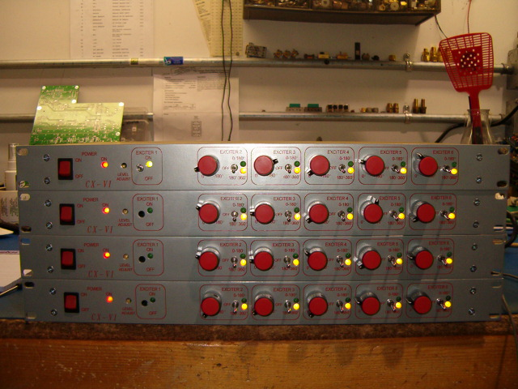

- OUR COMMON EXCITER CONTROLS 1-6 RF GENERATOR’S SIGNALS
- LIGHTWEIGHT CHASIS @ 3 LBS
- PHASE SHIFT CAPABILITIES RANGE FROM 0-180 AND 180-360 DEGREES
- 19” RACK MOUNT
- FREQUENCY STABILITY 0.05%
- BNC TYPE CONNECTORS USED FOR EASY SET-UP
- COMPATIABLE WITH ALL MODELS RF GENERATORS
- AIR COOLED
- 100-240 VAC VARIABLE AC INPUT
- INDEPENDENT SHUT OFF MODE FOR EACH CHANNEL
- MULTI-GANGED MODELS AVAILABLE (SEE BELOW)

APPLICATIONS:
- Multi-Stage Semiconductor Manufacturing
- Multi-Stage Plasma Coaters (Web, Metals, quartz, Etc)
- LCD Multi-Stage Coaters
- Multi-Stage Glass Coaters
- Multi-Stage Solar Panel Coaters

Mechanical
Height CX-11 3.500 ″ CX-16 5.250” CX-21 7.000”
Width 17.250 ″
Depth 10.500 ″

RF VII Inc. 1041 Glassboro Road, E-1 Williamstown , NJ 08094 Ph: 856-875-2121 Url: www.rfvii.com

