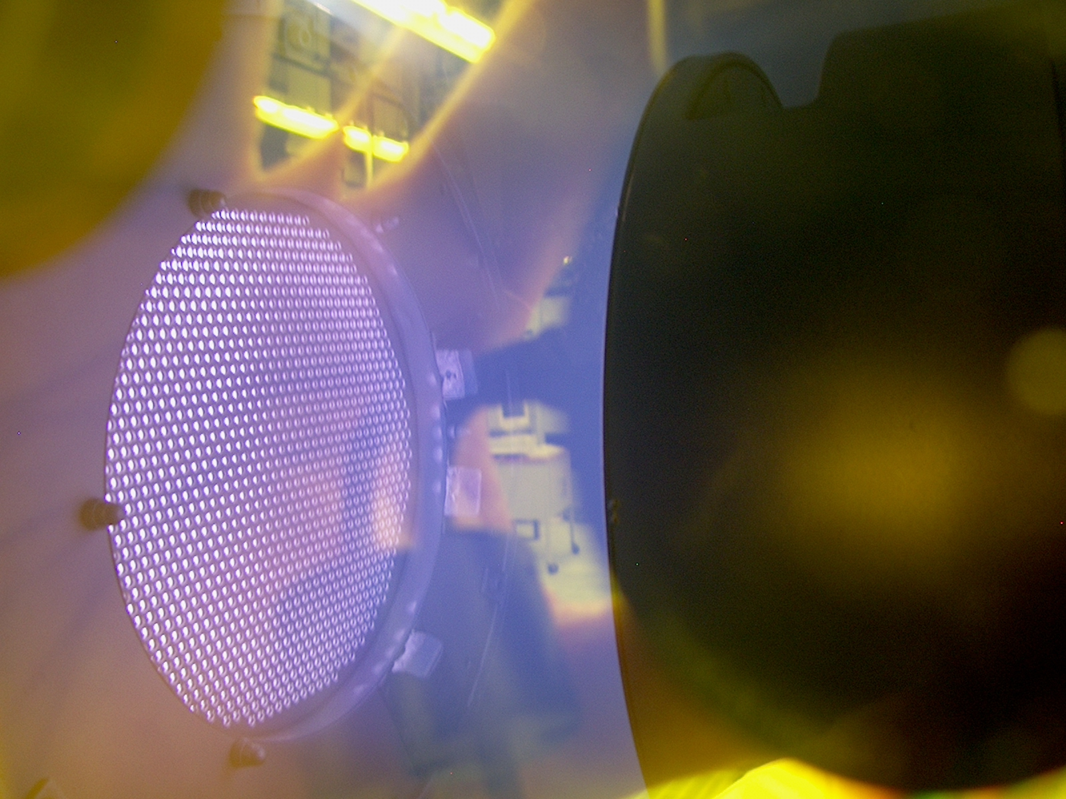


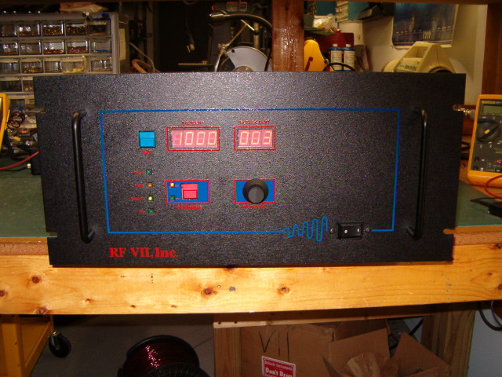

- RF-20-XIII IS OUR 2000 WATT RF GENERATOR @ 13.56 MHZ
- LIGHTWEIGHT CHASIS @ 48 LBS
- LINE INPUT IS 190-240 Single Phase Vac
- 19” RACK MOUNT
- USER FRIENDLY CONTROLS
- SOLID RF DESIGN FOR LONG TERM USE
- MODELS AVAILABLE @ 27.12 MHZ (see below)
- AIR COOLED
- 0-5 Vdc REMOTE CONTROL FEATURES (10 Vdc Option)
- BLANK FRONT PANEL OPTION AVAILABLE
- RS-232 Serial Control w/ pulsing 1-999 Hz / Duty Cycle 5-95%

APPLICATIONS:
- Semiconductor Manufacturing
- Plasma Coaters (Web, Metals, quartz, Etc)
- Plasma Etch (Solids, Clean, sterilization, Etc.)

Mechanical
Height 7.875 ″ / 20 cm
Width 17.00 ″ / 43.2 cm / w/ 19” rack
Depth 20.00 ″ / 50.8cm

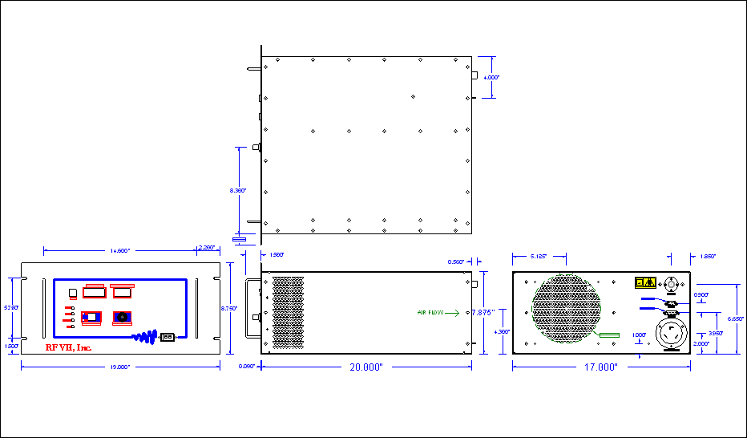

- RF-20-XXVII IS OUR 2000 WATT RF GENERATOR @ 27.12 MHZ
- LIGHTWEIGHT CHASIS @ 48 LBS
- LINE INPUT IS 190-240 Single Phase Vac
- 19” RACK MOUNT
- USER FRIENDLY CONTROLS
- SOLID RF DESIGN FOR LONG TERM USE
- AIR COOLED
- 0-5 Vdc REMOTE CONTROL FEATURES (10 Vdc Option)
- BLANK FRONT PANEL OPTION AVAILABLE
- RS-232 Serial Control w/ pulsing 1-999 Hz / Duty Cycle 5-95%

APPLICATIONS:
- ICP Plasma Torch
- MassSpec Plasma Source
- Induction Heating
- Medical Tooling

RF VII Inc. 1041 Glassboro Road, E-1 Williamstown , NJ 08094 Ph: 856-875-2121 Url: www.rfvii.com

