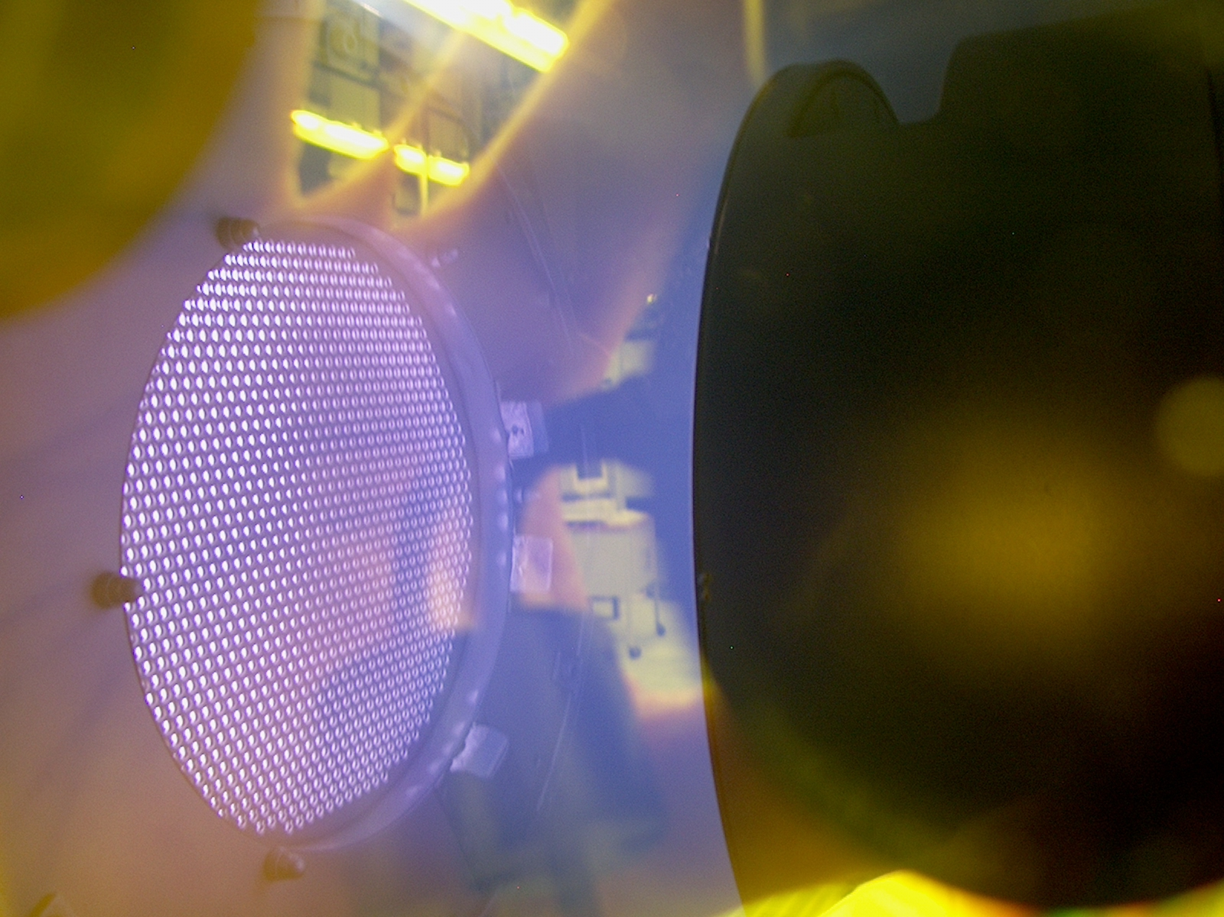


Height

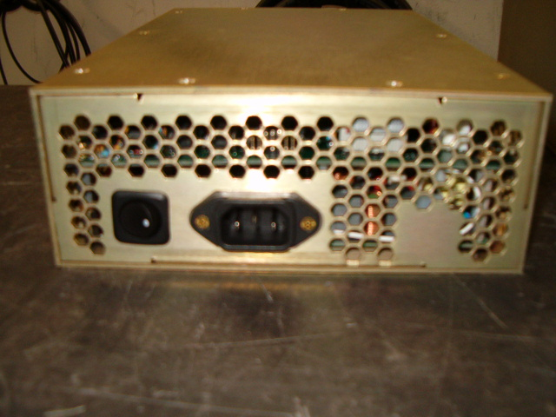

- RF-1-XIII IS OUR 100 WATT RF GENERATOR @ 13.56 MHZ
- LIGHTWEIGHT CHASIS @ 4 LBS
- LINE INPUT IS 100-240 Vac
- SMALL FOOTPRINT MOUNT
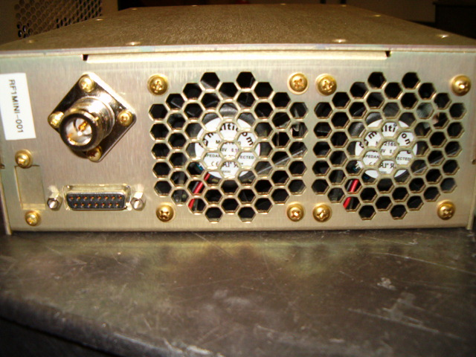
- USER FRIENDLY CONTROLS
- SOLID RF DESIGN FOR LONG TERM USE
- MODELS AVAILABLE SEE BELOW @ 27.12 MHZ
- AIR COOLED
- 0-5 Vdc VOLTAGE CONTROL FEATURES (10 Vdc Option)
- ALL REMOTE CONTROL
- RS-232 Serial Control w/ pulsing 1-999 Hz / Duty Cycle 5-95%

APPLICATIONS:
- Semiconductor Manufacturing
- Plasma Coaters (Web, Metals, quartz, Etc)
- Plasma Etch (Solids, Clean, sterilization, Etc.)

Mechanical
Height 2.90 ″ / 7-4 cm
Width 7.50 ″ / 19.1 cm
Depth 11.50 ″ / 29.2 cm

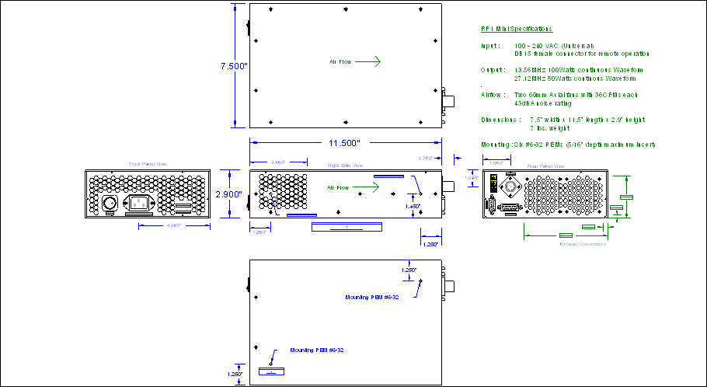

- RF-1-XXVII IS OUR 100 WATT RF GENERATOR @ 27.12 MHZ
- LIGHTWEIGHT CHASIS @ 4 LBS
- LINE INPUT IS 100-240 Vac
- SMALL FOOTPRINT MOUNT
- USER FRIENDLY CONTROLS
- SOLID RF DESIGN FOR LONG TERM USE
- AIR COOLED
- 0-5 Vdc VOLTAGE CONTROL FEATURES (10 Vdc Option)
- ALL REMOTE CONTROL
- RS-232 Serial Control w/ pulsing 1-999 Hz / Duty Cycle 5-95%

APPLICATIONS:
- ICP Plasma
- Induction Heating
- Medical Tooling

RF VII Inc. 1041 Glassboro Road, E-1 Williamstown , NJ 08094 Ph: 856-875-2121 Url: www.rfvii.com

