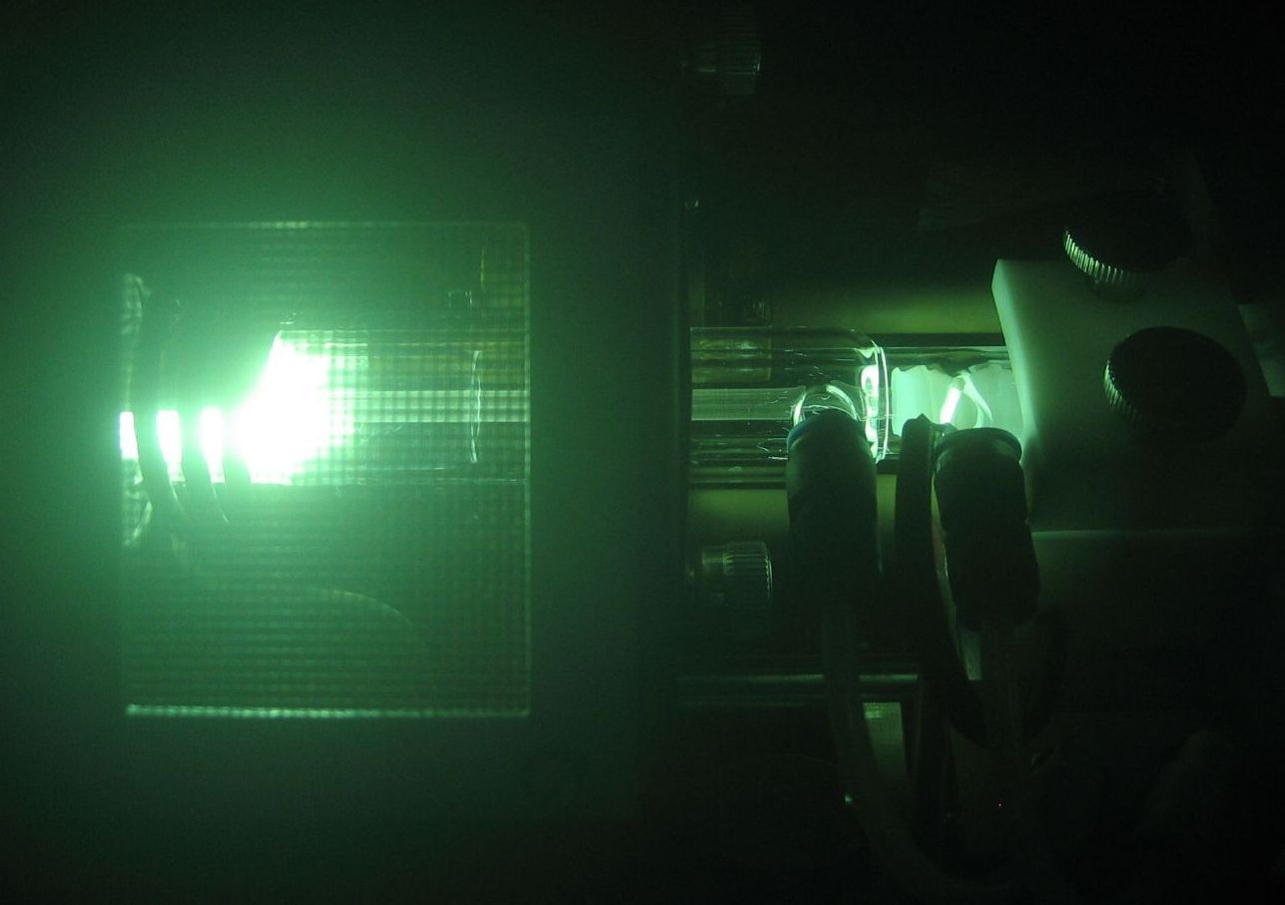


Height

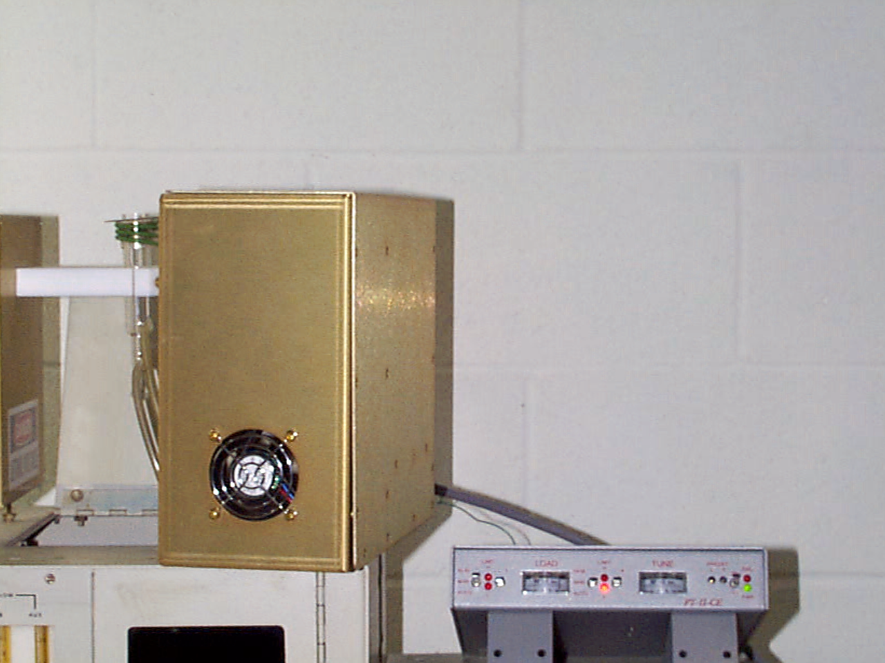

- ATN-ICP is our AUTOTUNING NETWORKS FOR 27.12 & 40.68 MHZ
- LIGHTWEIGHT CHASIS @ 18 LBS
- ADJUSTABLE BROAD IMPEDENCE RANGE
- SMALL FOOTPRINT MOUNT
- WATER COOLED OUTPUT INDUCTORS
- POWER HANDLING 2000 WATTS
- RETROFITS INTO MOST ICP MASSSPEC SYSTEMS
- AIR COOLED / WATER COOLED
- USES PT-II-CE CONTROLLER (See Below)
- AUTO / MANUAL/ REMOTE OPERATION
- WORKS WITH ANY 50 OHM LOAD TESTED RF GENERATOR

APPLICATIONS:
- Semiconductor Manufacturing
- Plasma Coaters (Web, Metals, quartz, Etc)
- Plasma Etch (Solids, Clean, sterilization, Etc.)

Mechanical
Height 9.500 ″ / 7-4 cm
Width 11.625″ / 19.1 cm
Depth 5.00″ / 29.2 cm

Mechanical
Height 1.750 ″
Width 8.500 ″
Depth 9.750 ″
Rack Mount Ext. 19.000 ″ (Option)

- PT-II-CE IS A UNIVERSAL TUNER CONTROLLER
- LIGHTWEIGHT CHASIS @ 2 LBS
- LINE INPUT IS 100-240 Vac
- SMALL FOOTPRINT MOUNT
- USER FRIENDLY CONTROLS
- SOLID RF DESIGN FOR LONG TERM USE
- OFFERS INTERNAL PRESET or EXTERNAL CONTROL PRESETS
- REMOTE SIGNAL AND CONTROL INTERFACE
- ALLOWS REMOTE, AUTO, and MANUAL FUNCTIONS
- CAN BE USED TO DIRECTLY REPLACE EXISTING CONTROLLERS

APPLICATIONS:
- ICP Plasma
- Induction Heating
- Medical Tooling

RF VII Inc. 1041 Glassboro Road, E-1 Williamstown , NJ 08094 Ph: 856-875-2121 Url: www.rfvii.com

