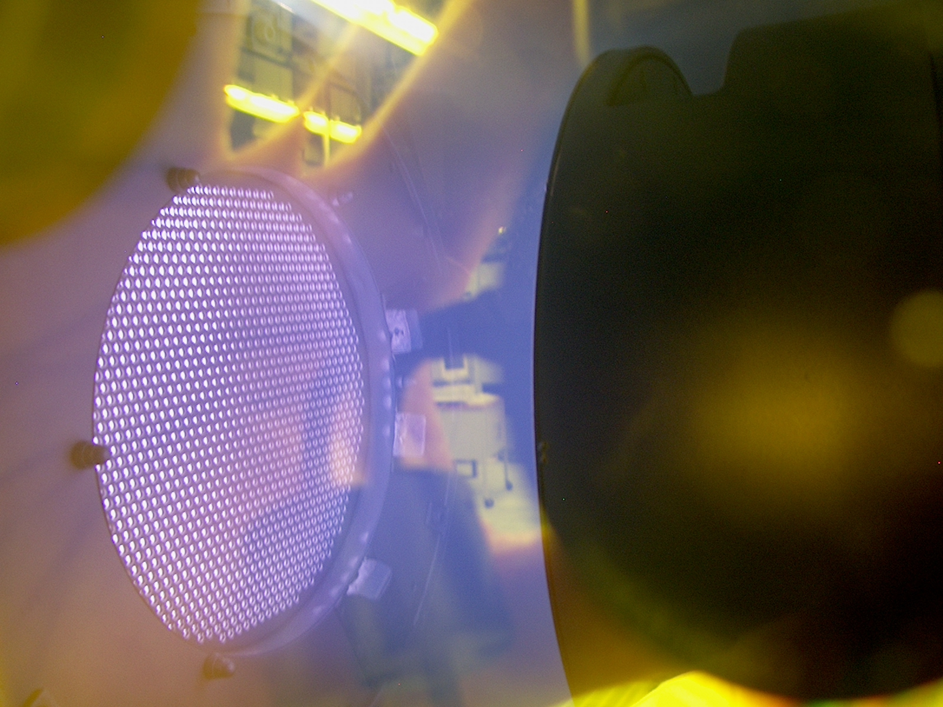


Height

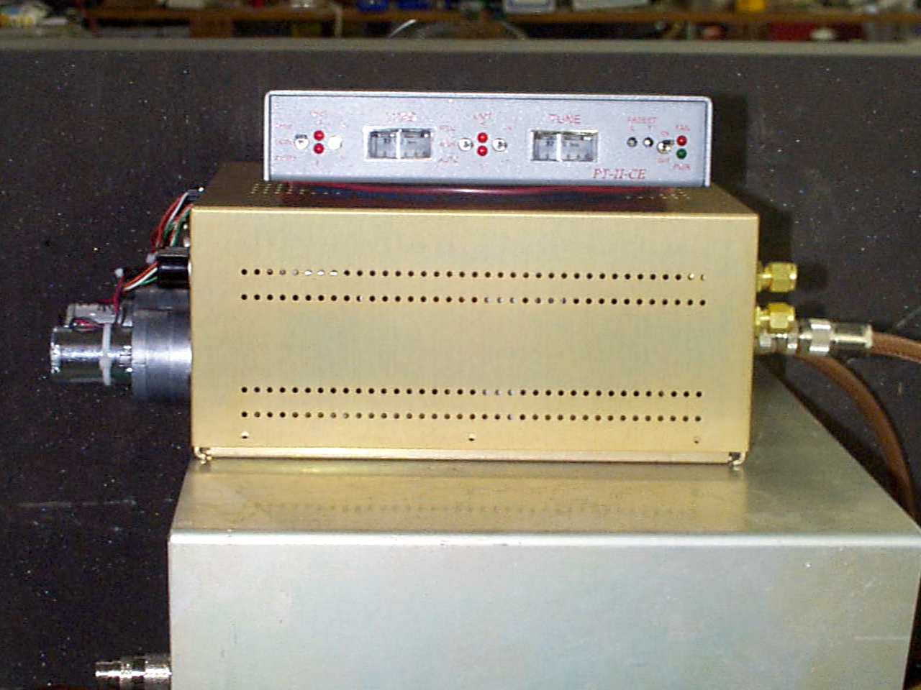

- ATN-5/10 is our AUTO INTERNAL MATCHNET FOR 13.56 MHZ
- AIM MODELS HAVE BUILT IN FULL CONTROLLERS
- LIGHTWEIGHT CHASIS @ 10 LBS
- ADJUSTABLE BROAD IMPEDENCE RANGE
- SMALL FOOTPRINT MOUNT
- MULTIPLE RF OUTPUT TYPES FROM STUD, N, and HN TYPES
- POWER HANDLING 500 w (ATN-5) and 700 w (ATN-10)
- AIM MODELS AVAILABLE IN ALL ATN POWER LEVELS
- AIR COOLED / WATER COOLED
- REQUIRES EXTERNAL +/- 15 Vdc FROM SYSTEM PS SOURCE
- AUTO / MANUAL / REMOTE OPERATION / PRESETS
- WORKS WITH ANY 50 OHM LOAD TESTED RF GENERATOR

APPLICATIONS:
- Semiconductor Manufacturing
- Plasma Coaters (Web, Metals, quartz, Etc)
- Plasma Etch (Solids, Clean, sterilization, Etc.)

Mechanical
Height 5.00 ″ / 7-4 cm
Width 8.75 ″ / 19.1 cm
Depth 15.00 ″ / 29.2 cm

Mechanical
Height 5.500 ″
Width 8.000 ″
Depth 11.750 ″

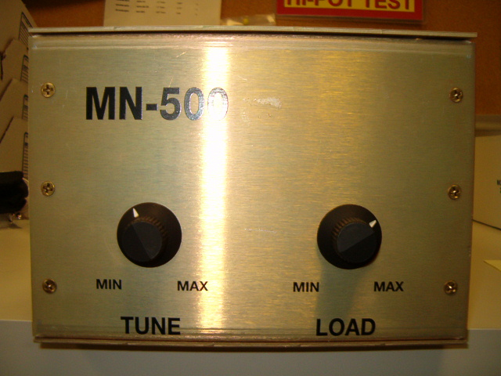

- MN-500 IS OUR LOW POWER MANUAL TUNER
- LIGHTWEIGHT CHASIS @ 5 LBS
- ADJUSTABLE KNOBS
- SMALL FOOTPRINT MOUNT
- MULTIPLE RF OUTPUT TYPES FROM STUD, N, HN TYPES
- ADJUSTABLE BROAD IMPEDENCE RANGE
- AIR COOLED
- CAN BE USED TO DIRECTLY REPLACE EXISTING CONTROLLERS

APPLICATIONS:
- ICP Plasma
- Induction Heating
- Medical Tooling

RF VII Inc. 1041 Glassboro Road, E-1 Williamstown , NJ 08094 Ph: 856-875-2121 Url: www.rfvii.com

